Test Case: tc008_SPX_Dev5_Validacion_Boton_Remove_Administrador_Menu
Step 1 - Enter username and password and click to button Enter : Credentials Entered
Image file-name: QC_Testing-runTestMultipleTimes-nov. 20 2025, 02 39 41 p. m.

Image file-name: QC_Testing-runTestMultipleTimes-nov. 20 2025, 02 39 42 p. m.

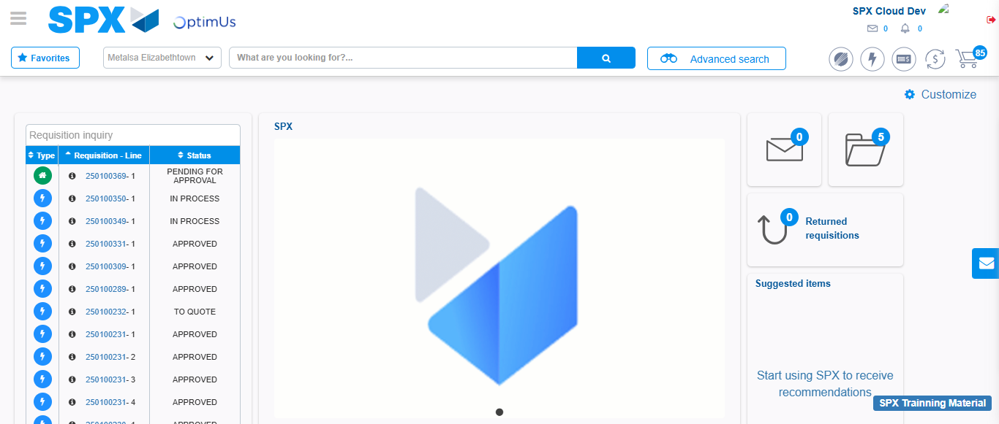Image file-name: QC_Testing-tc001_SPX_Dev5_Validar_Filtro_Campo_MenuName_Administrador_Roles_Menu-nov. 20 2025, 02 40 13 p. m.

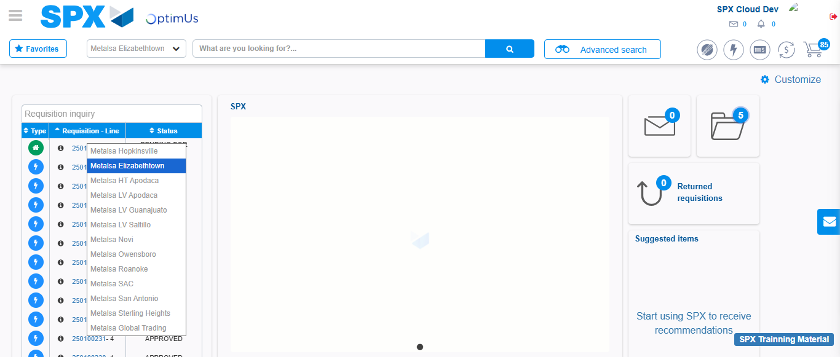Image file-name: QC_Testing-tc002_SPX_Dev5_Validar_Filtro_Campo_URLPath_Administrador_Roles_Menu-nov. 20 2025, 02 40 36 p. m.

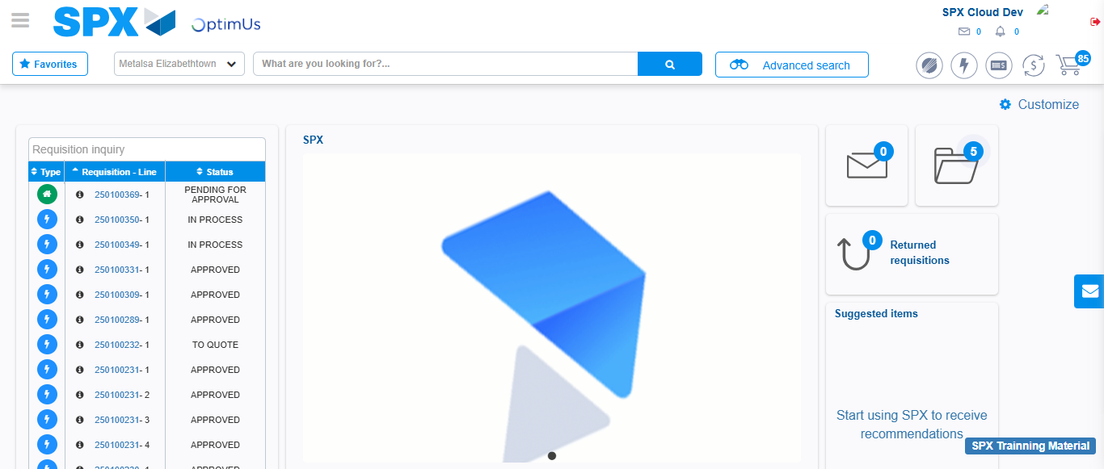Image file-name: QC_Testing-tc003_SPX_Dev5_Validar_Funcionalidad_Botones_Add_Remove_Administrador_Roles_Menu-nov. 20 2025, 02 41 01 p. m.

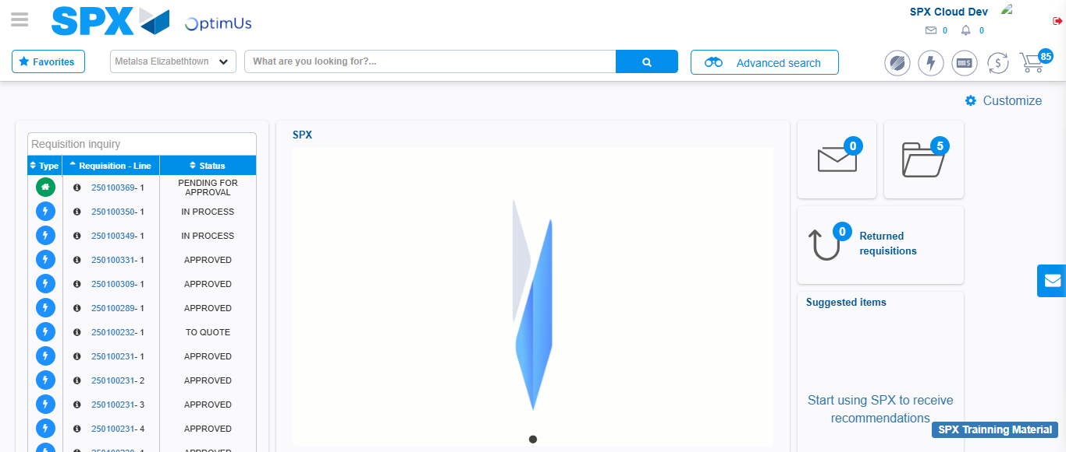Image file-name: QC_Testing-tc004_SPX_Dev5_Validacion_Filtro_Campo_MenuName_Administrador_Menu-nov. 20 2025, 02 41 30 p. m.

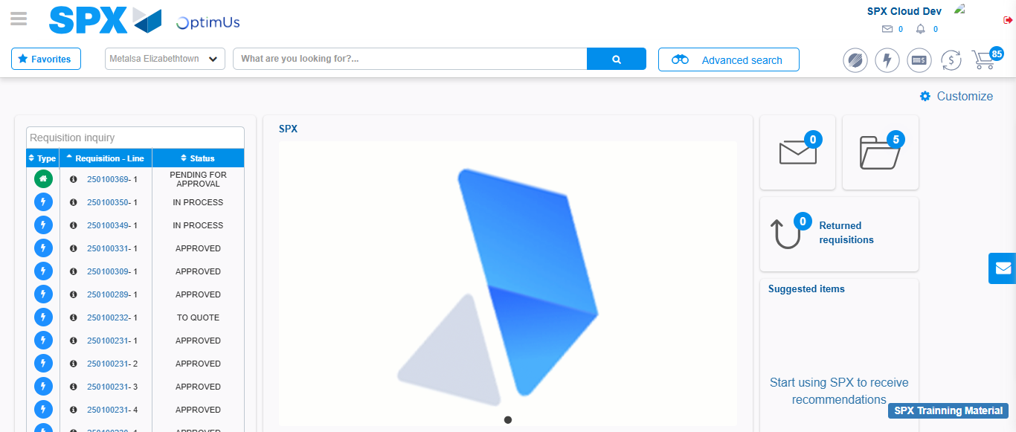Image file-name: QC_Testing-tc005_SPX_Dev5_Validacion_Filtro_Campo_URLPath_Administrador_Menu-nov. 20 2025, 02 41 51 p. m.

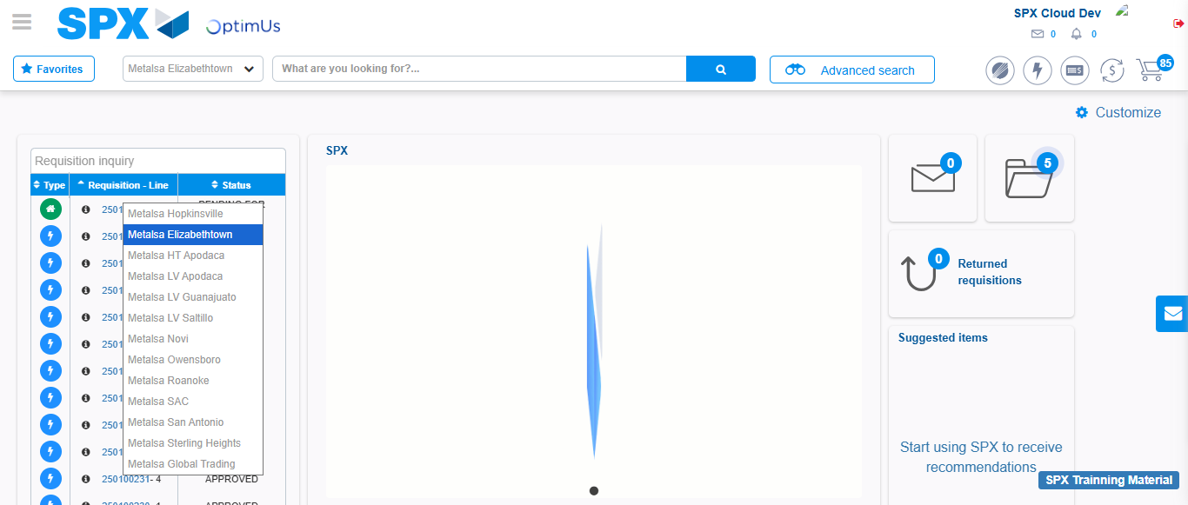Image file-name: QC_Testing-tc006_SPX_Dev5_Validacion_Boton_AddNewMenu_Administrador_Menu-nov. 20 2025, 02 42 19 p. m.

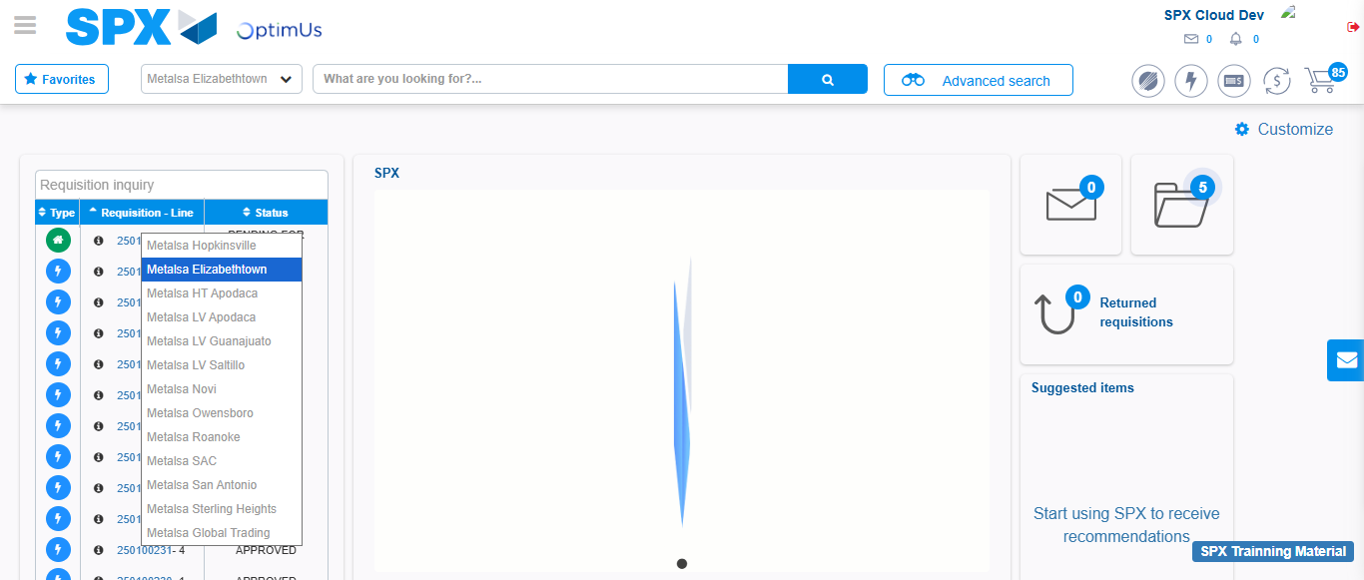Image file-name: QC_Testing-tc007_SPX_Dev5_Validacion_Boton_Edit_Administrador_Menu-nov. 20 2025, 02 42 50 p. m.

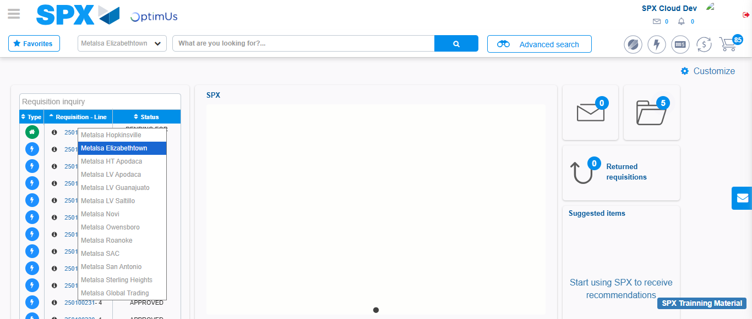Image file-name: QC_Testing-tc008_SPX_Dev5_Validacion_Boton_Remove_Administrador_Menu-nov. 20 2025, 02 43 20 p. m.

Step 2 - Select to UEN and Access to Administrador Roles Menu: UEN Correctly selected and Correct access
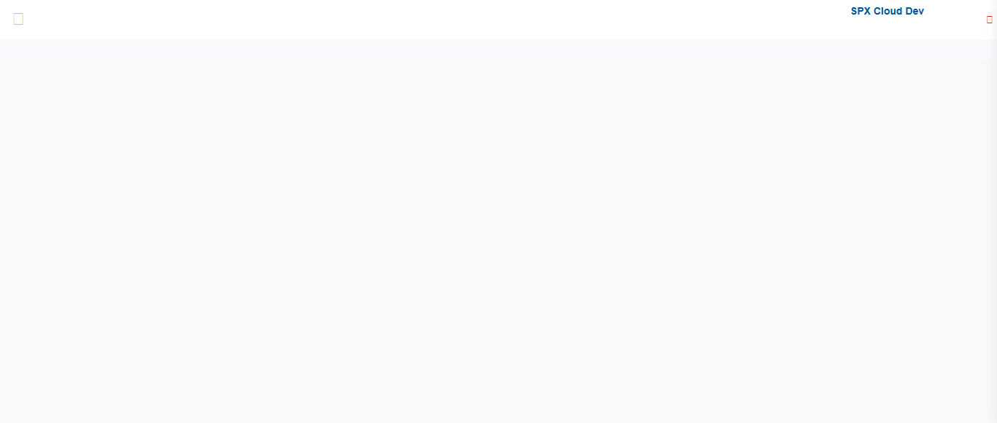Image file-name: QC_Testing-runTestMultipleTimes-nov. 20 2025, 02 39 51 p. m.

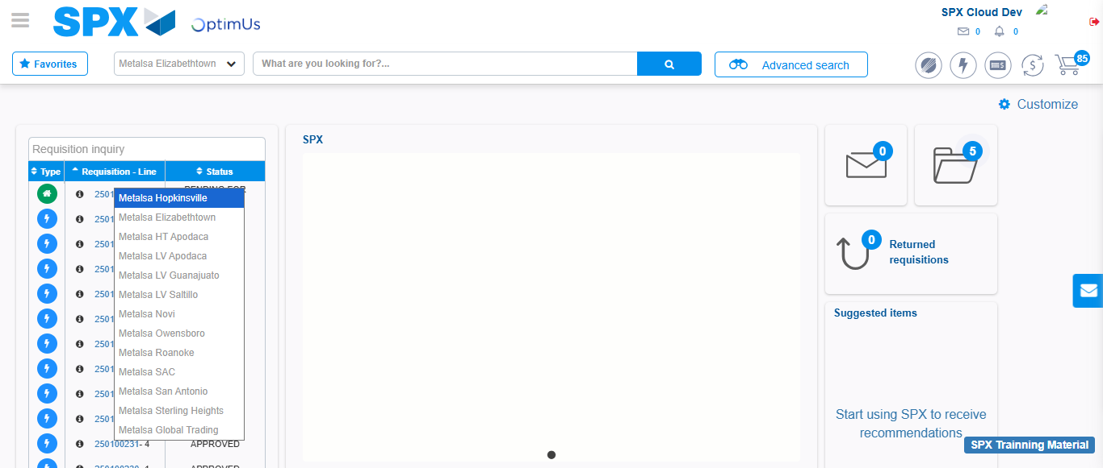Image file-name: QC_Testing-runTestMultipleTimes-nov. 20 2025, 02 39 52 p. m.

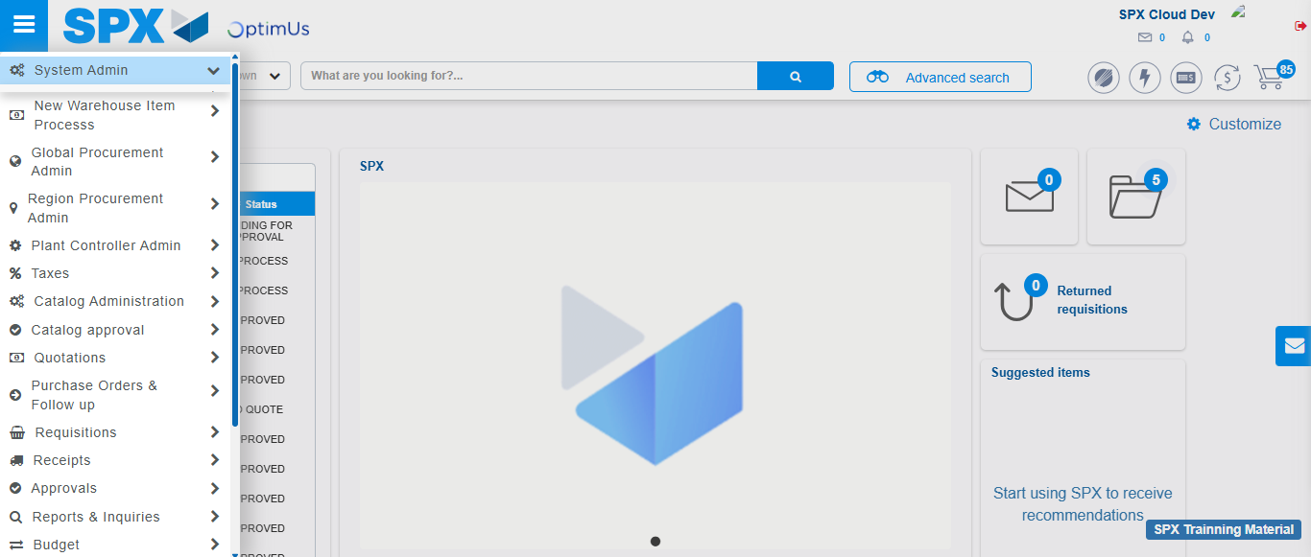Image file-name: QC_Testing-runTestMultipleTimes-nov. 20 2025, 02 39 53 p. m.

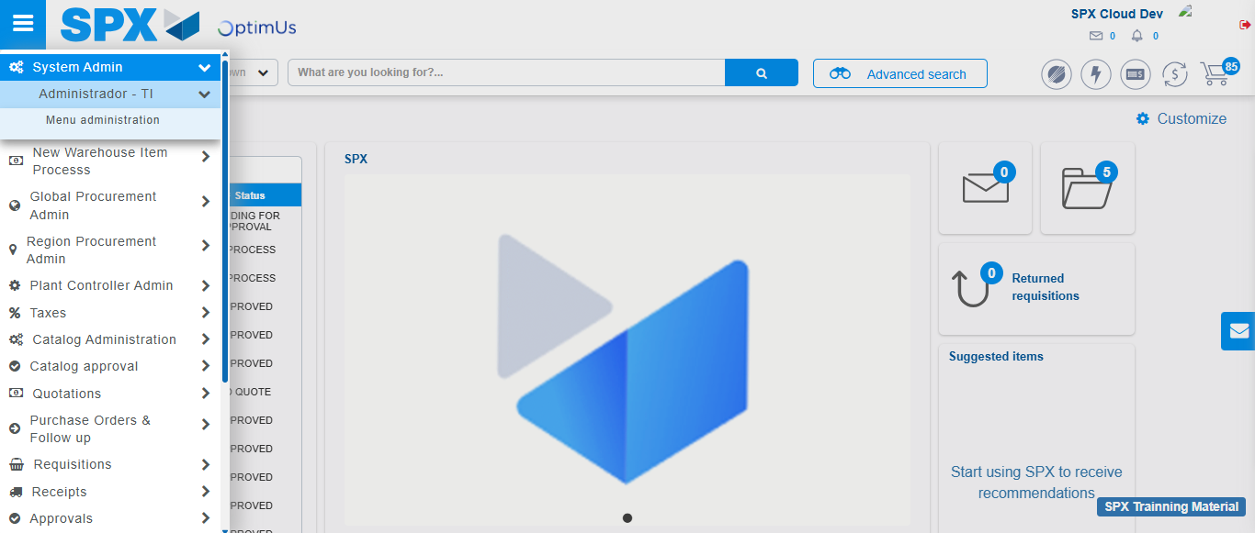Image file-name: QC_Testing-runTestMultipleTimes-nov. 20 2025, 02 39 54 p. m.

Image file-name: QC_Testing-runTestMultipleTimes-nov. 20 2025, 02 39 57 p. m.

Image file-name: QC_Testing-tc001_SPX_Dev5_Validar_Filtro_Campo_MenuName_Administrador_Roles_Menu-nov. 20 2025, 02 40 13 p. m.

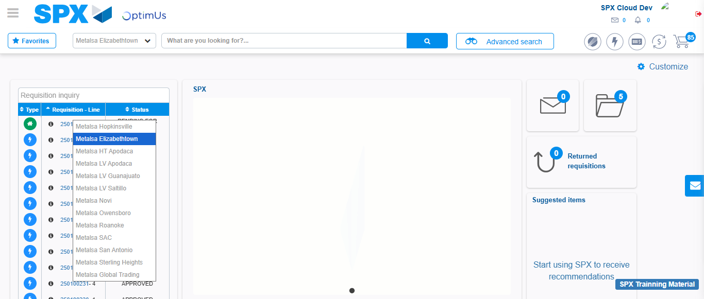Image file-name: QC_Testing-tc001_SPX_Dev5_Validar_Filtro_Campo_MenuName_Administrador_Roles_Menu-nov. 20 2025, 02 40 14 p. m.

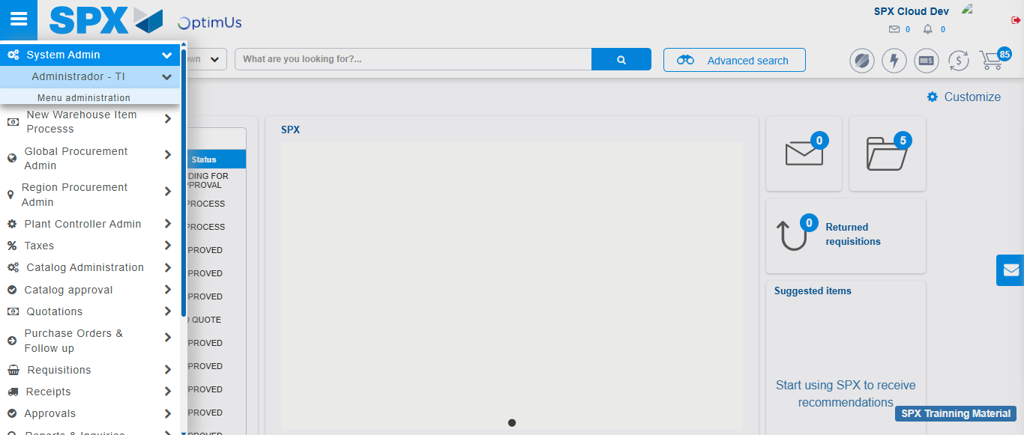Image file-name: QC_Testing-tc001_SPX_Dev5_Validar_Filtro_Campo_MenuName_Administrador_Roles_Menu-nov. 20 2025, 02 40 15 p. m.

Image file-name: QC_Testing-tc001_SPX_Dev5_Validar_Filtro_Campo_MenuName_Administrador_Roles_Menu-nov. 20 2025, 02 40 17 p. m.

Image file-name: QC_Testing-tc002_SPX_Dev5_Validar_Filtro_Campo_URLPath_Administrador_Roles_Menu-nov. 20 2025, 02 40 36 p. m.

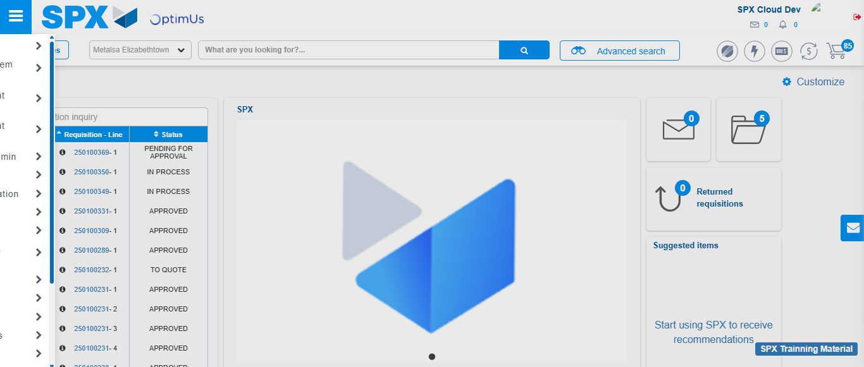Image file-name: QC_Testing-tc002_SPX_Dev5_Validar_Filtro_Campo_URLPath_Administrador_Roles_Menu-nov. 20 2025, 02 40 37 p. m.

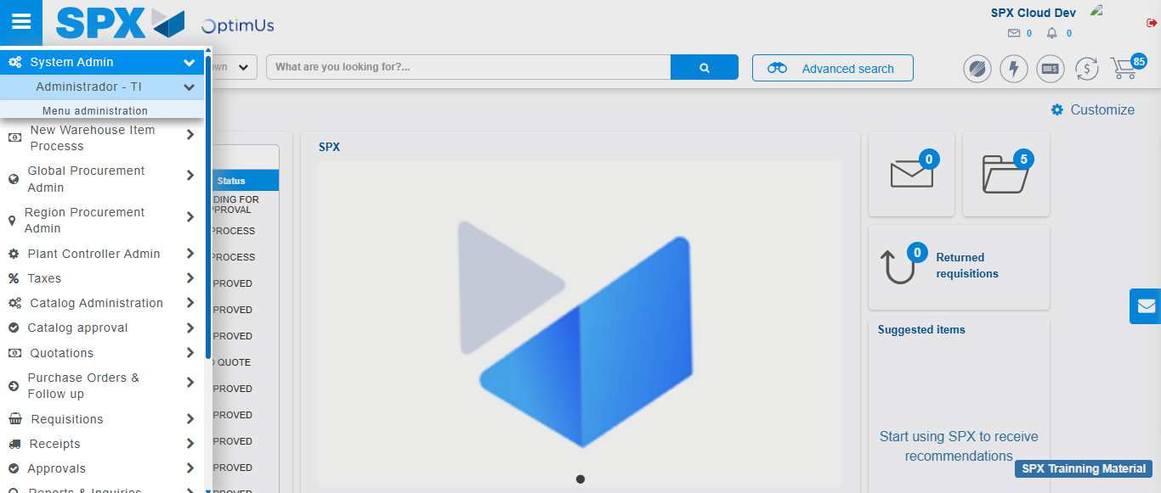Image file-name: QC_Testing-tc002_SPX_Dev5_Validar_Filtro_Campo_URLPath_Administrador_Roles_Menu-nov. 20 2025, 02 40 38 p. m.

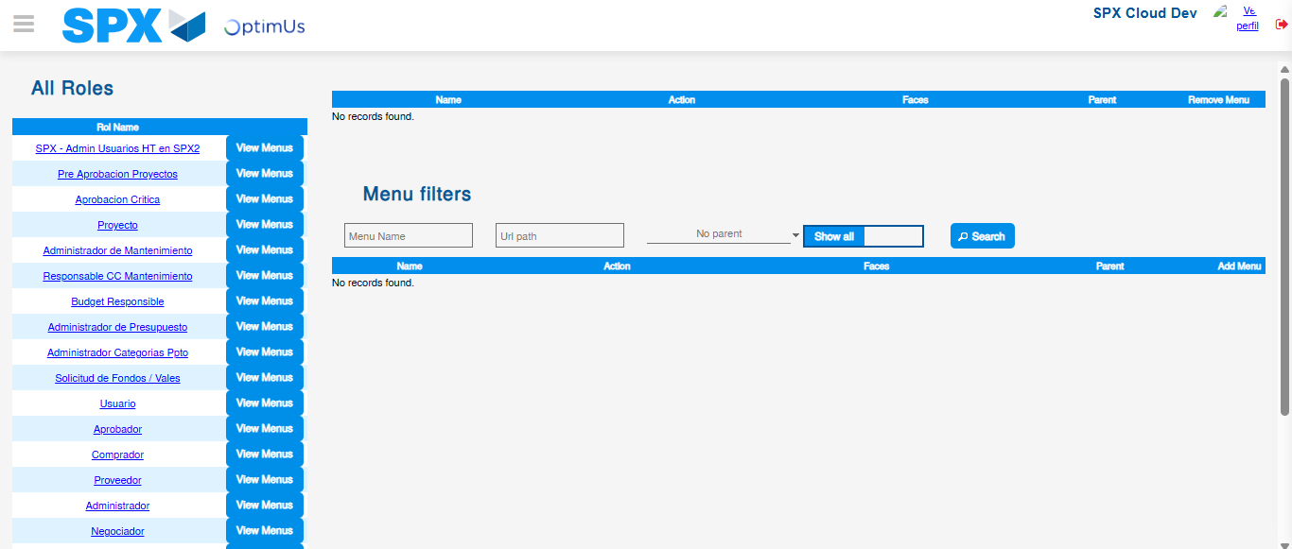Image file-name: QC_Testing-tc002_SPX_Dev5_Validar_Filtro_Campo_URLPath_Administrador_Roles_Menu-nov. 20 2025, 02 40 40 p. m.

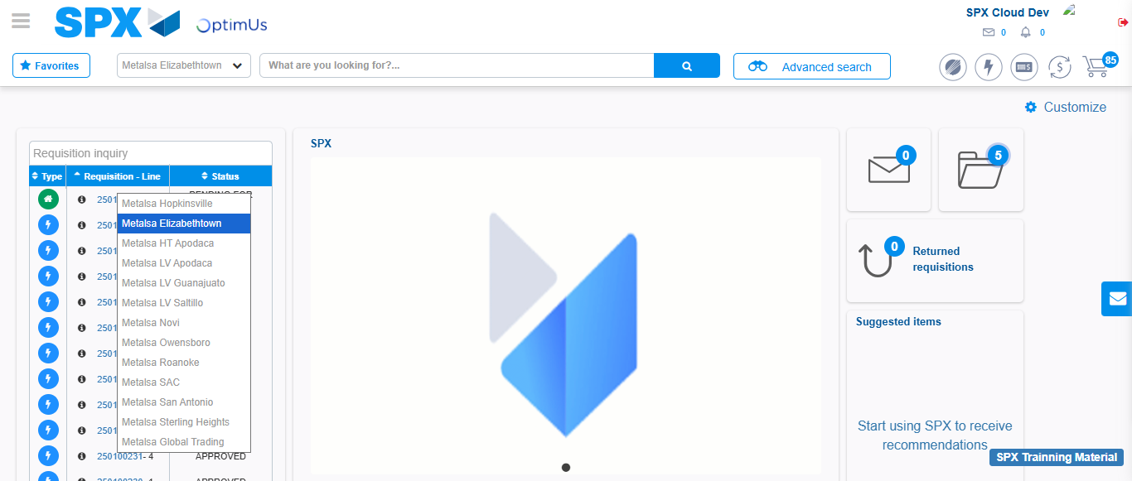Image file-name: QC_Testing-tc003_SPX_Dev5_Validar_Funcionalidad_Botones_Add_Remove_Administrador_Roles_Menu-nov. 20 2025, 02 41 02 p. m.

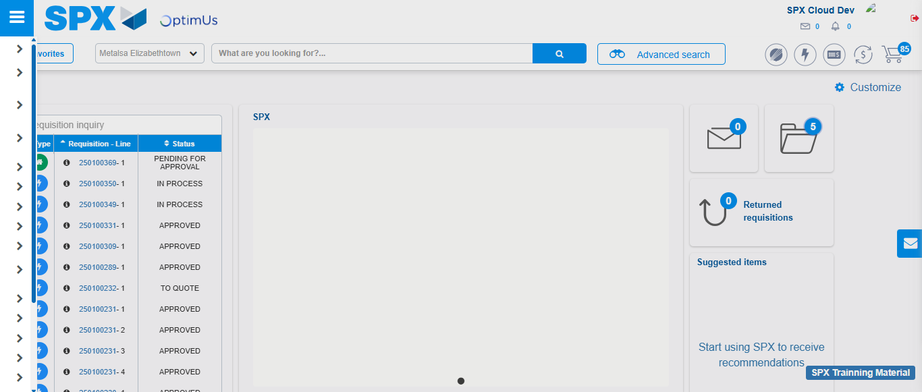Image file-name: QC_Testing-tc003_SPX_Dev5_Validar_Funcionalidad_Botones_Add_Remove_Administrador_Roles_Menu-nov. 20 2025, 02 41 03 p. m.

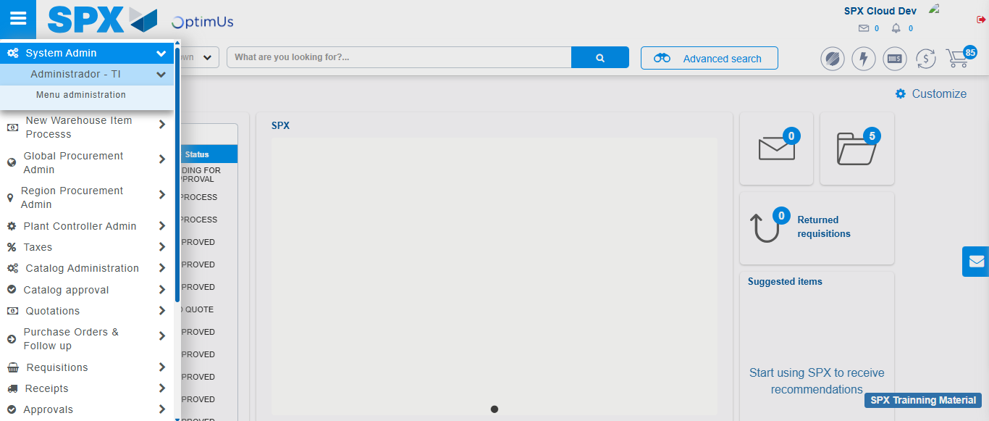Image file-name: QC_Testing-tc003_SPX_Dev5_Validar_Funcionalidad_Botones_Add_Remove_Administrador_Roles_Menu-nov. 20 2025, 02 41 04 p. m.

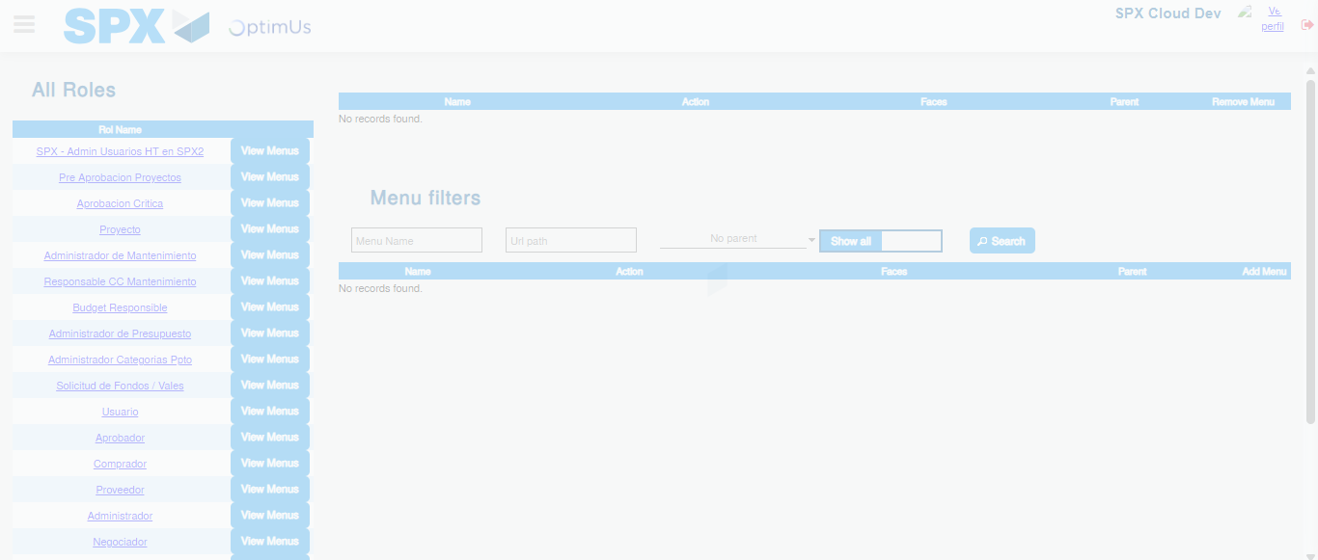Image file-name: QC_Testing-tc003_SPX_Dev5_Validar_Funcionalidad_Botones_Add_Remove_Administrador_Roles_Menu-nov. 20 2025, 02 41 06 p. m.

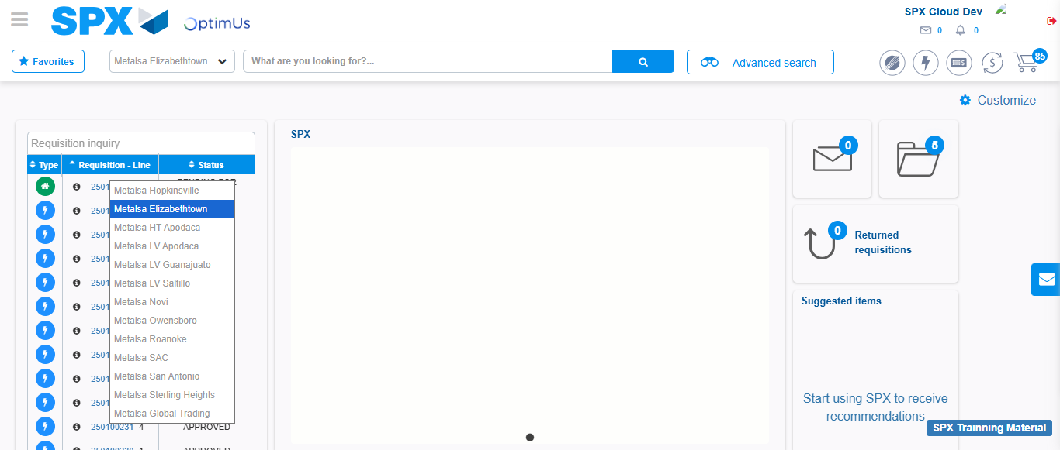Image file-name: QC_Testing-tc004_SPX_Dev5_Validacion_Filtro_Campo_MenuName_Administrador_Menu-nov. 20 2025, 02 41 31 p. m.

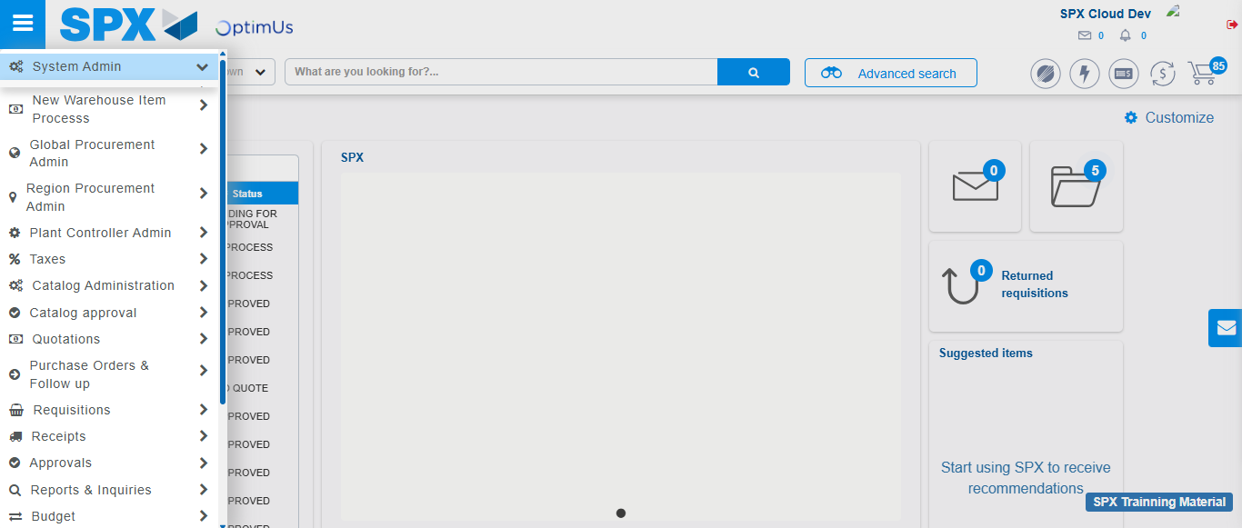Image file-name: QC_Testing-tc004_SPX_Dev5_Validacion_Filtro_Campo_MenuName_Administrador_Menu-nov. 20 2025, 02 41 32 p. m.

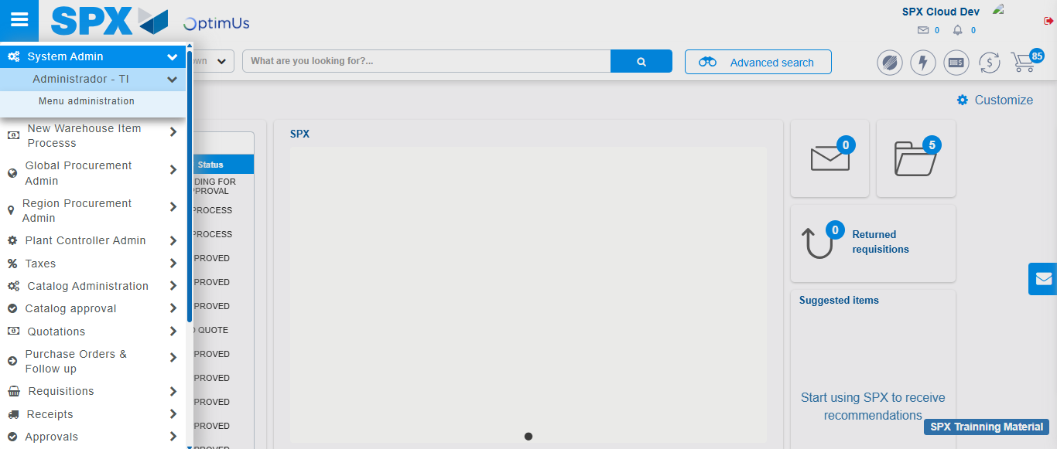Image file-name: QC_Testing-tc004_SPX_Dev5_Validacion_Filtro_Campo_MenuName_Administrador_Menu-nov. 20 2025, 02 41 33 p. m.

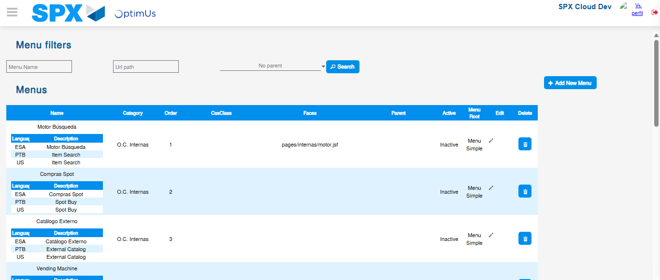Image file-name: QC_Testing-tc004_SPX_Dev5_Validacion_Filtro_Campo_MenuName_Administrador_Menu-nov. 20 2025, 02 41 34 p. m.

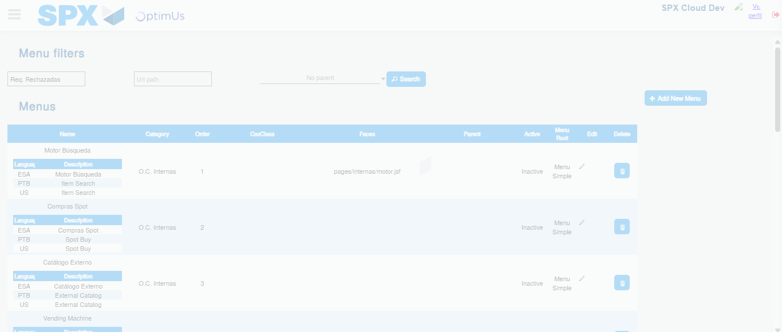Image file-name: QC_Testing-tc004_SPX_Dev5_Validacion_Filtro_Campo_MenuName_Administrador_Menu-nov. 20 2025, 02 41 35 p. m.

Image file-name: QC_Testing-tc005_SPX_Dev5_Validacion_Filtro_Campo_URLPath_Administrador_Menu-nov. 20 2025, 02 41 51 p. m.

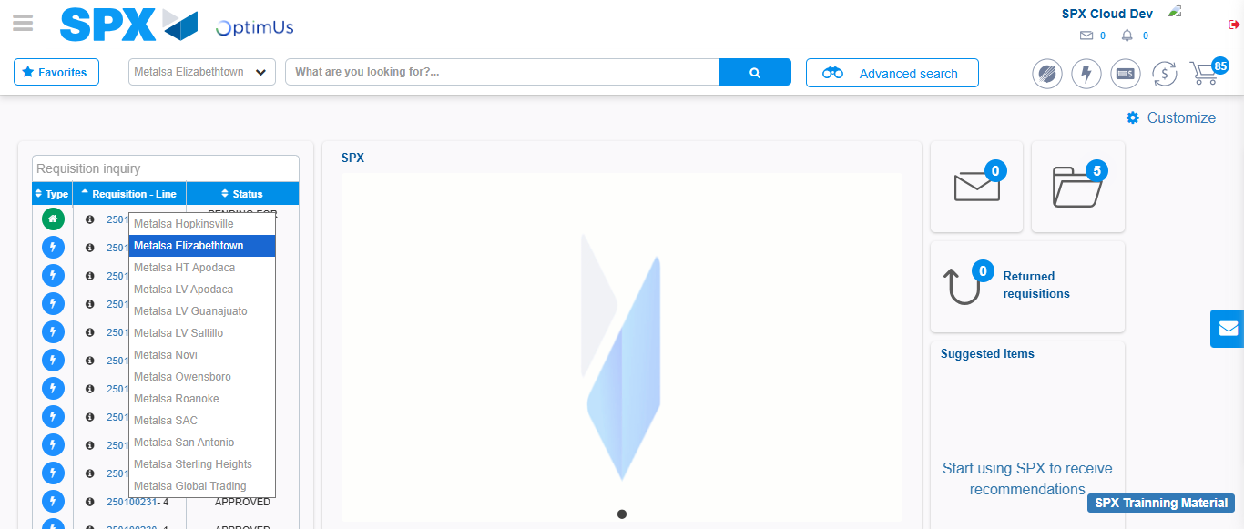Image file-name: QC_Testing-tc005_SPX_Dev5_Validacion_Filtro_Campo_URLPath_Administrador_Menu-nov. 20 2025, 02 41 52 p. m.

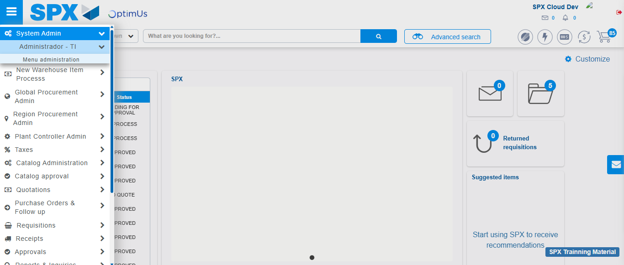Image file-name: QC_Testing-tc005_SPX_Dev5_Validacion_Filtro_Campo_URLPath_Administrador_Menu-nov. 20 2025, 02 41 53 p. m.

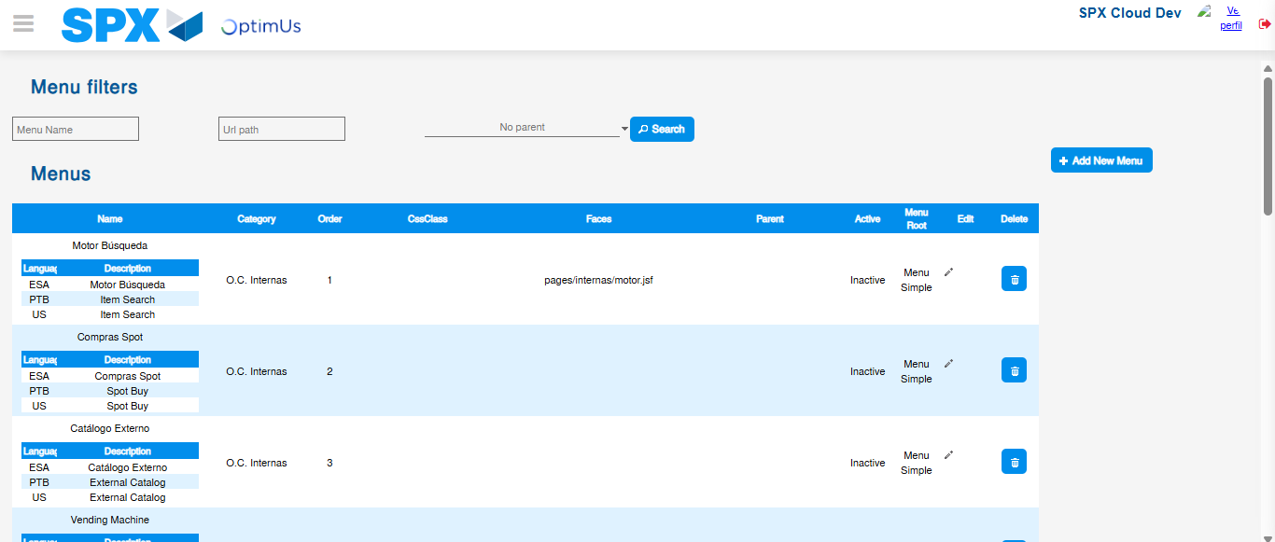Image file-name: QC_Testing-tc005_SPX_Dev5_Validacion_Filtro_Campo_URLPath_Administrador_Menu-nov. 20 2025, 02 42 00 p. m.

Image file-name: QC_Testing-tc006_SPX_Dev5_Validacion_Boton_AddNewMenu_Administrador_Menu-nov. 20 2025, 02 42 19 p. m.

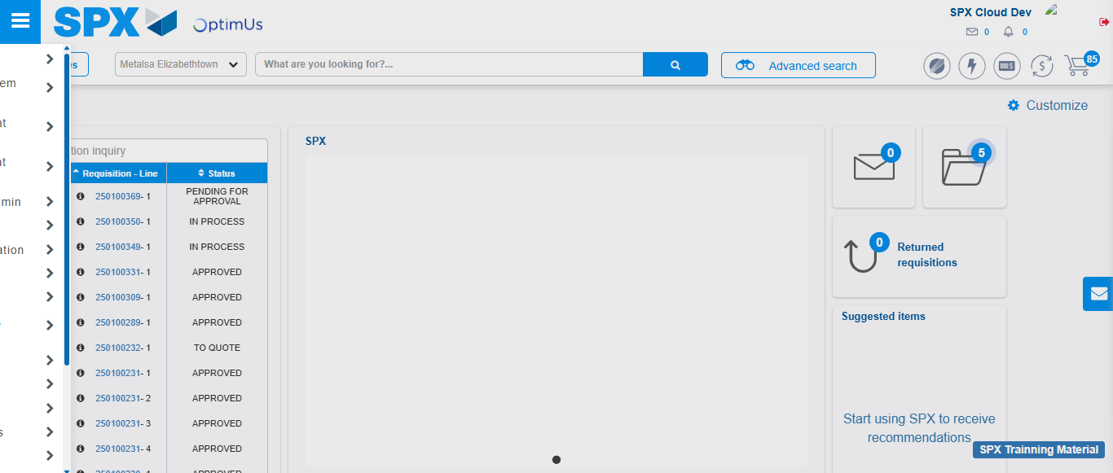Image file-name: QC_Testing-tc006_SPX_Dev5_Validacion_Boton_AddNewMenu_Administrador_Menu-nov. 20 2025, 02 42 20 p. m.

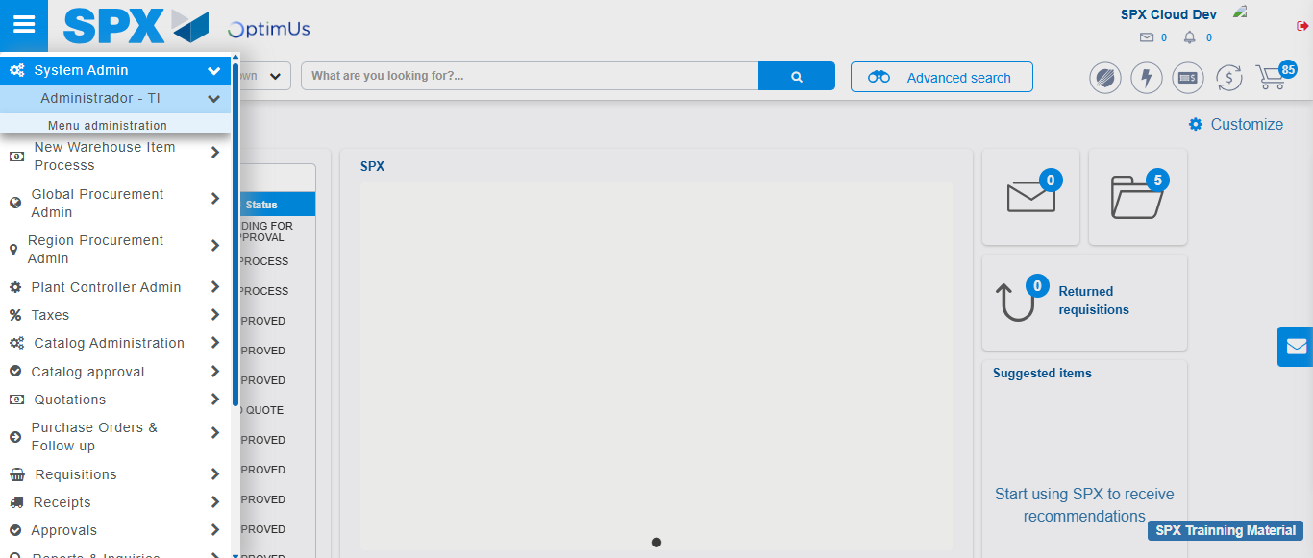Image file-name: QC_Testing-tc006_SPX_Dev5_Validacion_Boton_AddNewMenu_Administrador_Menu-nov. 20 2025, 02 42 21 p. m.

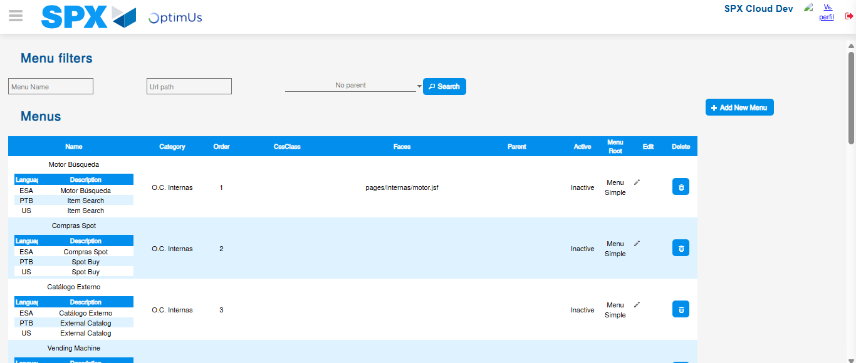Image file-name: QC_Testing-tc006_SPX_Dev5_Validacion_Boton_AddNewMenu_Administrador_Menu-nov. 20 2025, 02 42 24 p. m.

Image file-name: QC_Testing-tc007_SPX_Dev5_Validacion_Boton_Edit_Administrador_Menu-nov. 20 2025, 02 42 50 p. m.

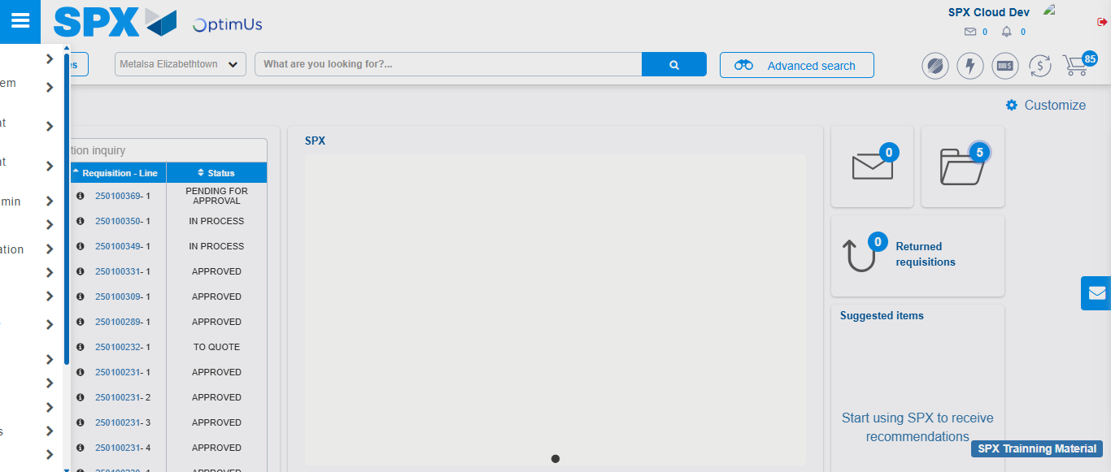Image file-name: QC_Testing-tc007_SPX_Dev5_Validacion_Boton_Edit_Administrador_Menu-nov. 20 2025, 02 42 51 p. m.

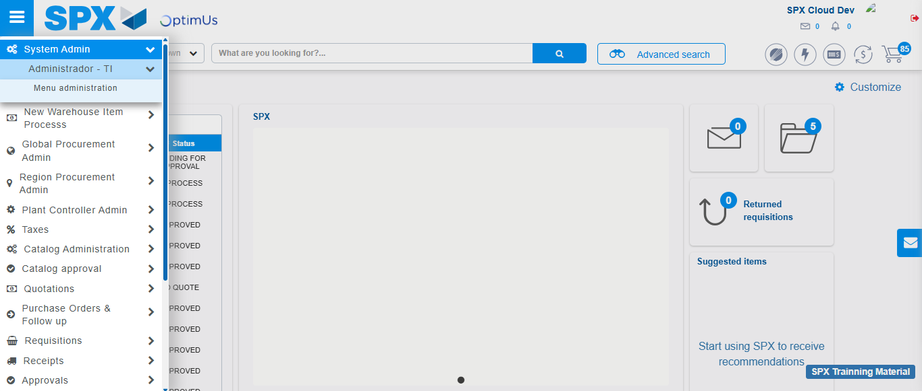Image file-name: QC_Testing-tc007_SPX_Dev5_Validacion_Boton_Edit_Administrador_Menu-nov. 20 2025, 02 42 52 p. m.

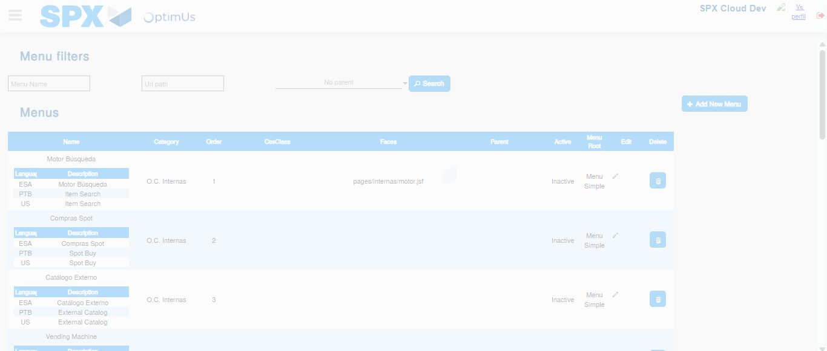Image file-name: QC_Testing-tc007_SPX_Dev5_Validacion_Boton_Edit_Administrador_Menu-nov. 20 2025, 02 42 54 p. m.

Image file-name: QC_Testing-tc008_SPX_Dev5_Validacion_Boton_Remove_Administrador_Menu-nov. 20 2025, 02 43 20 p. m.

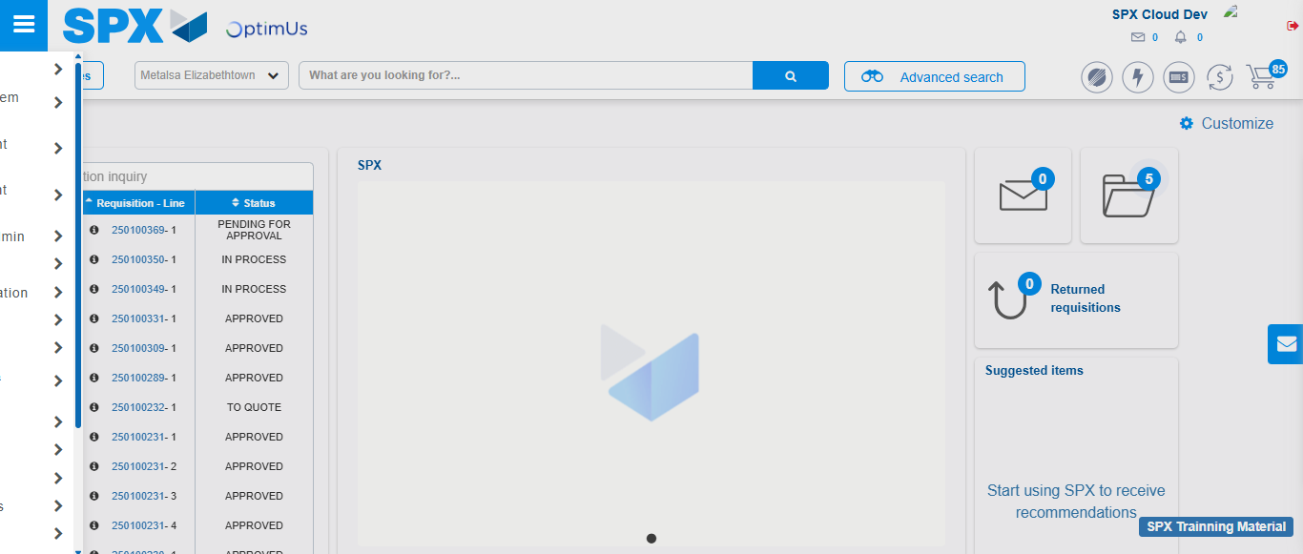Image file-name: QC_Testing-tc008_SPX_Dev5_Validacion_Boton_Remove_Administrador_Menu-nov. 20 2025, 02 43 21 p. m.

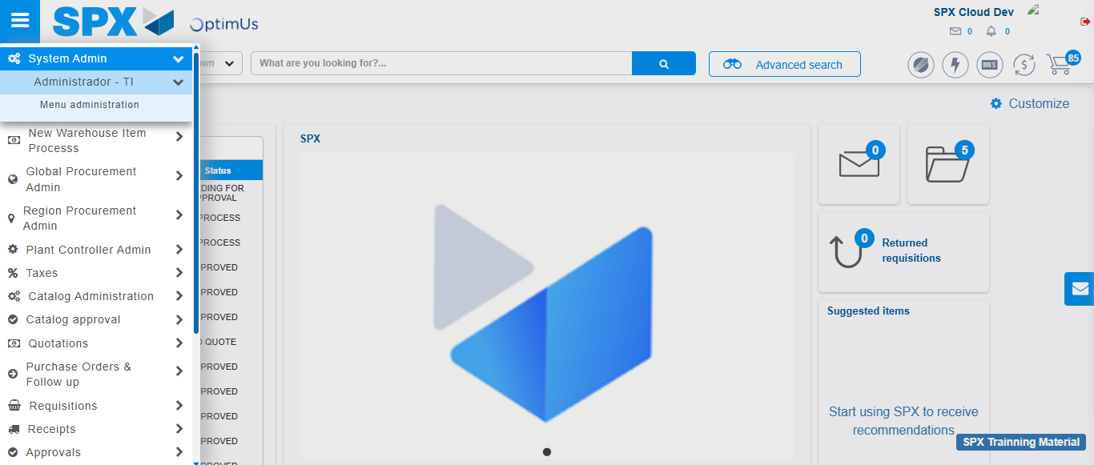Image file-name: QC_Testing-tc008_SPX_Dev5_Validacion_Boton_Remove_Administrador_Menu-nov. 20 2025, 02 43 22 p. m.

Image file-name: QC_Testing-tc008_SPX_Dev5_Validacion_Boton_Remove_Administrador_Menu-nov. 20 2025, 02 43 24 p. m.

Step 3 - Delete record: Record successfully deleted
Image file-name: QC_Testing-tc004_SPX_Dev5_Validacion_Filtro_Campo_MenuName_Administrador_Menu-nov. 20 2025, 02 41 35 p. m.

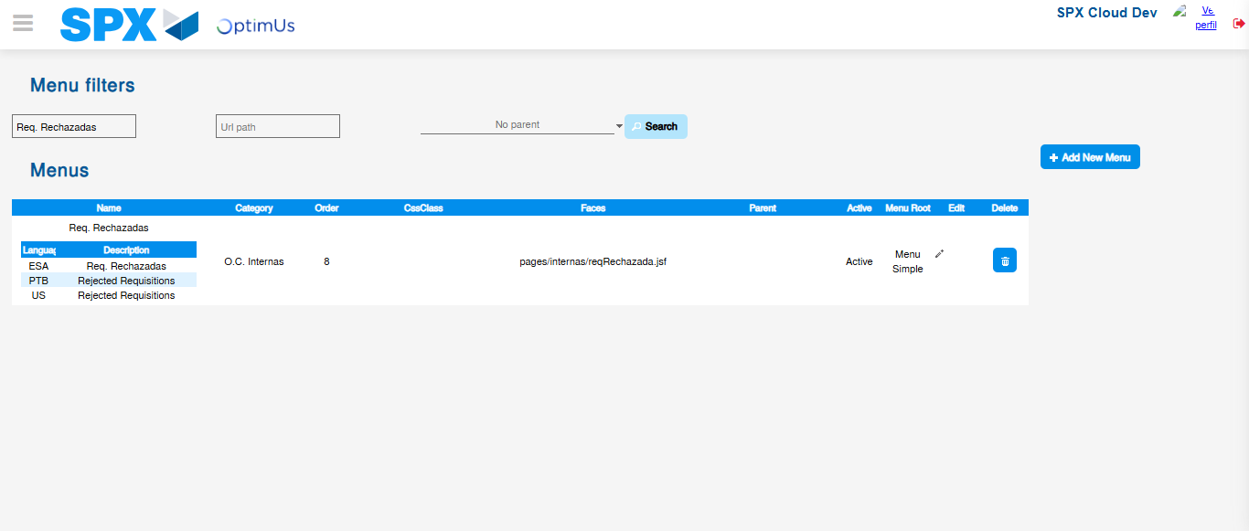Image file-name: QC_Testing-tc004_SPX_Dev5_Validacion_Filtro_Campo_MenuName_Administrador_Menu-nov. 20 2025, 02 41 36 p. m.

Image file-name: QC_Testing-tc005_SPX_Dev5_Validacion_Filtro_Campo_URLPath_Administrador_Menu-nov. 20 2025, 02 42 00 p. m.

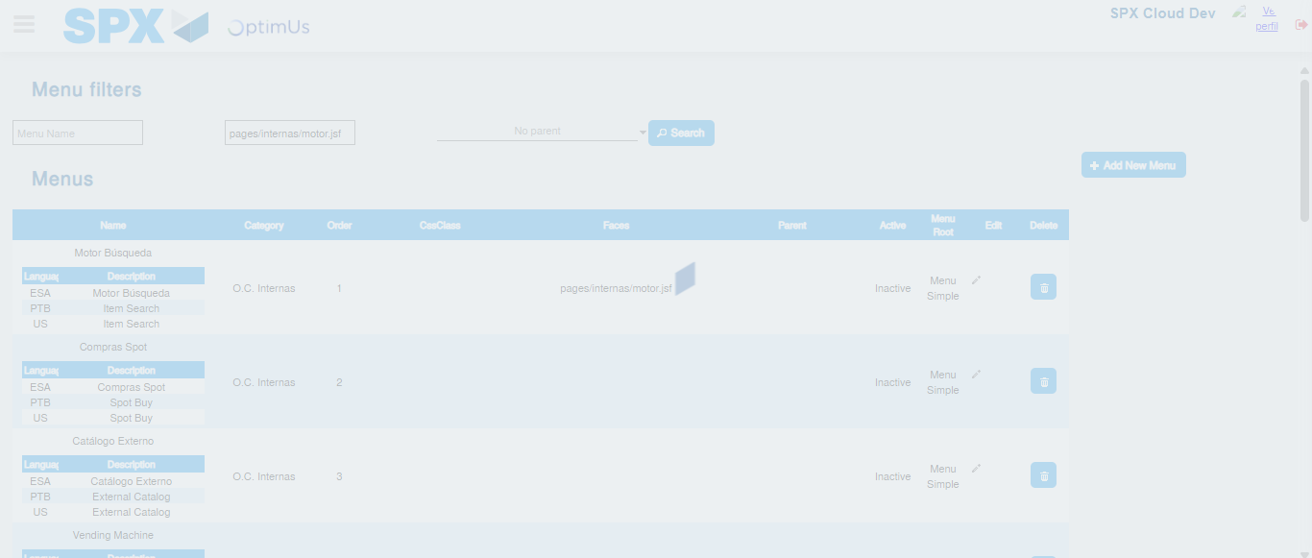Image file-name: QC_Testing-tc005_SPX_Dev5_Validacion_Filtro_Campo_URLPath_Administrador_Menu-nov. 20 2025, 02 42 01 p. m.

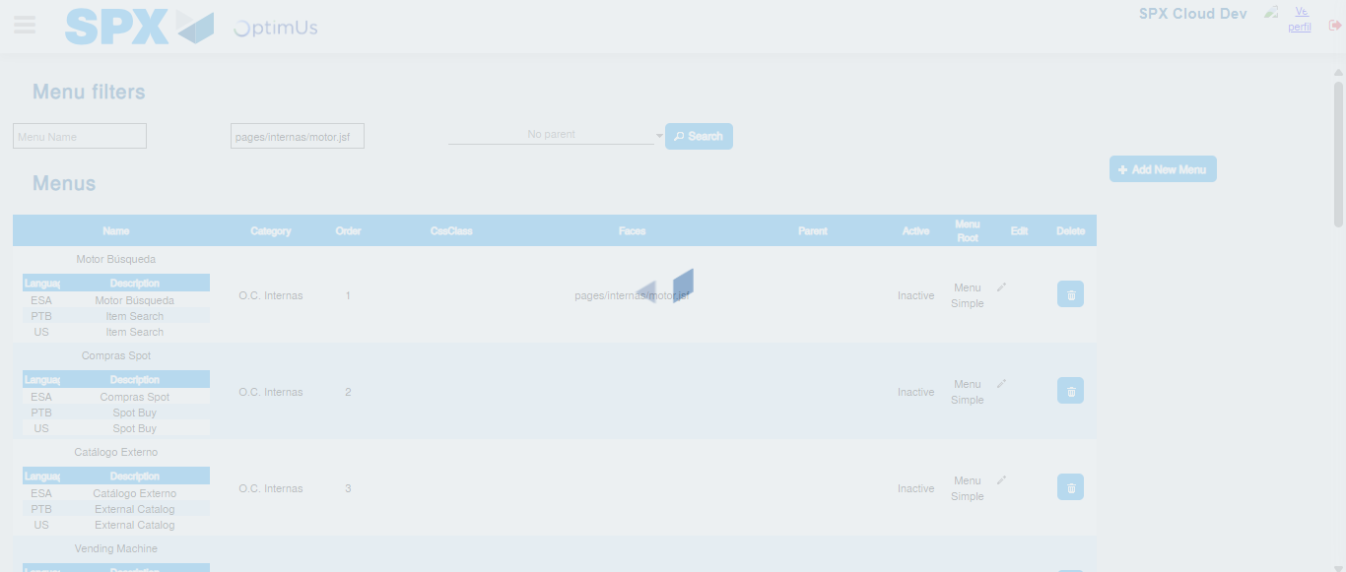Image file-name: QC_Testing-tc005_SPX_Dev5_Validacion_Filtro_Campo_URLPath_Administrador_Menu-nov. 20 2025, 02 42 02 p. m.

Image file-name: QC_Testing-tc006_SPX_Dev5_Validacion_Boton_AddNewMenu_Administrador_Menu-nov. 20 2025, 02 42 24 p. m.

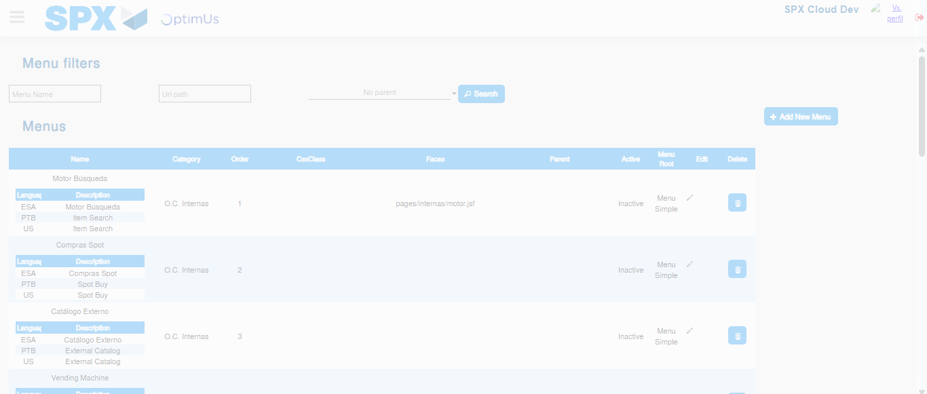Image file-name: QC_Testing-tc006_SPX_Dev5_Validacion_Boton_AddNewMenu_Administrador_Menu-nov. 20 2025, 02 42 25 p. m.

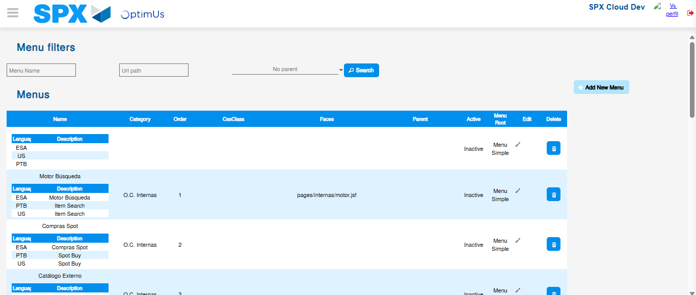Image file-name: QC_Testing-tc006_SPX_Dev5_Validacion_Boton_AddNewMenu_Administrador_Menu-nov. 20 2025, 02 42 28 p. m.

Image file-name: QC_Testing-tc007_SPX_Dev5_Validacion_Boton_Edit_Administrador_Menu-nov. 20 2025, 02 42 54 p. m.

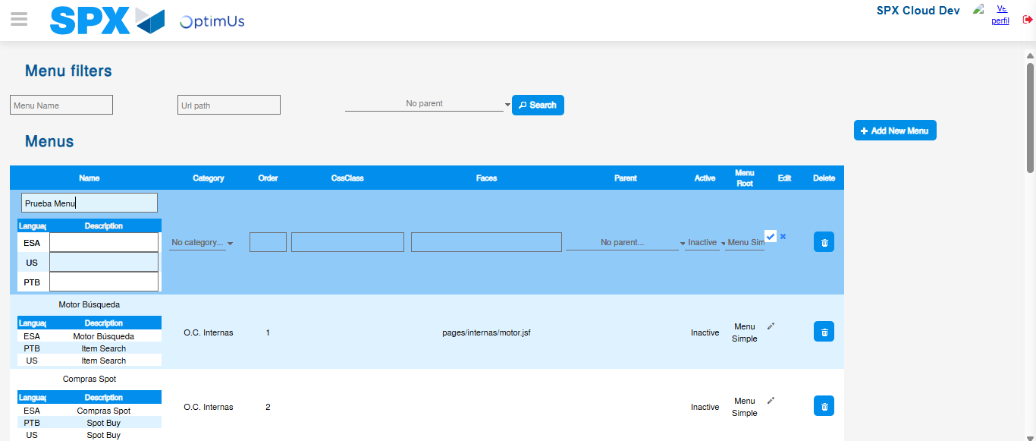Image file-name: QC_Testing-tc007_SPX_Dev5_Validacion_Boton_Edit_Administrador_Menu-nov. 20 2025, 02 42 58 p. m.

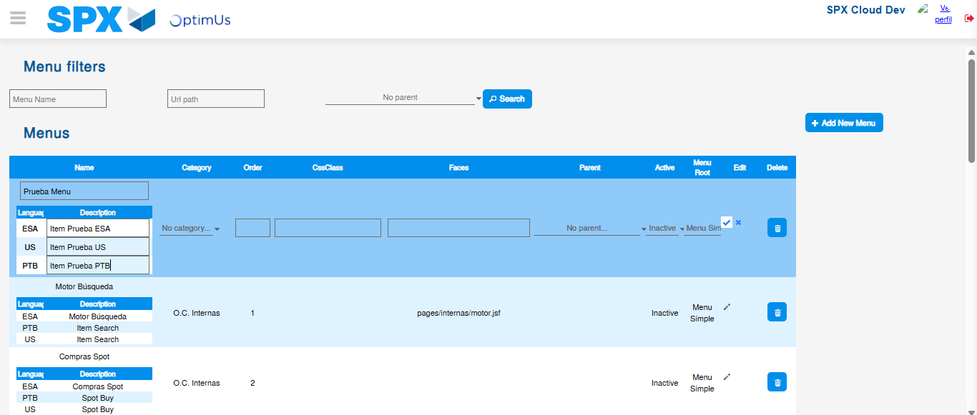Image file-name: QC_Testing-tc007_SPX_Dev5_Validacion_Boton_Edit_Administrador_Menu-nov. 20 2025, 02 42 59 p. m.

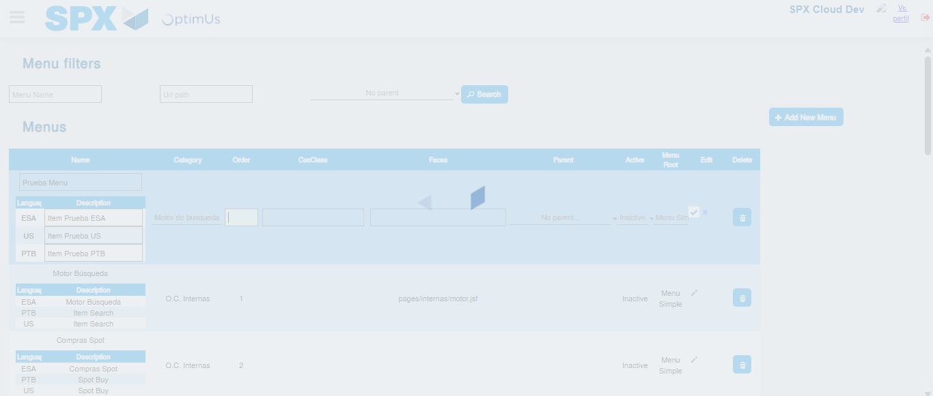Image file-name: QC_Testing-tc007_SPX_Dev5_Validacion_Boton_Edit_Administrador_Menu-nov. 20 2025, 02 43 00 p. m.

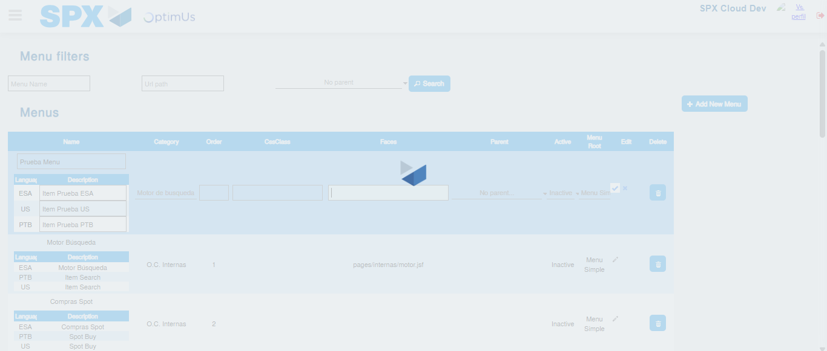Image file-name: QC_Testing-tc007_SPX_Dev5_Validacion_Boton_Edit_Administrador_Menu-nov. 20 2025, 02 43 01 p. m.

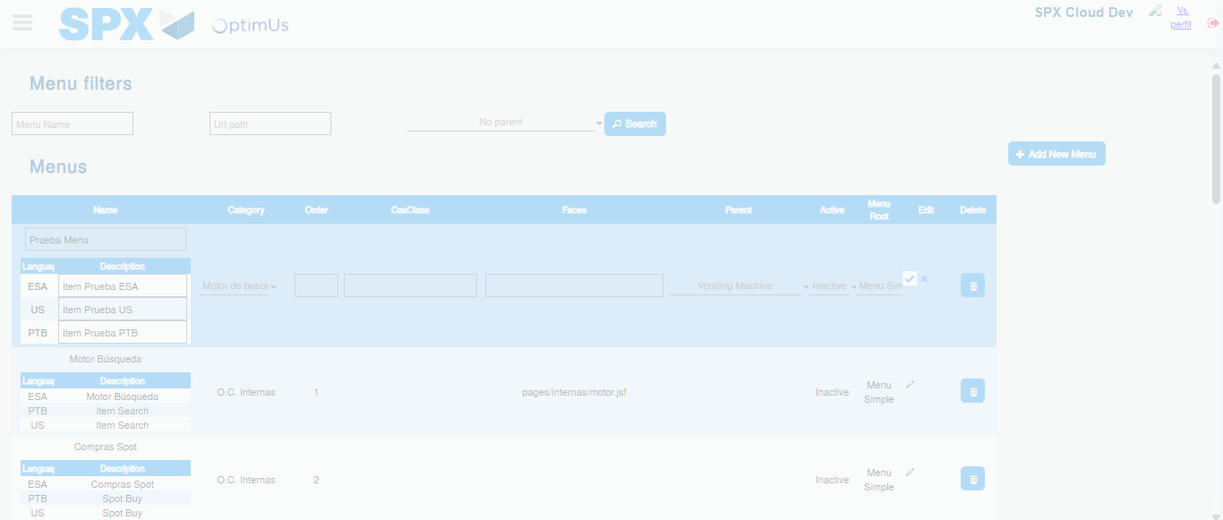Image file-name: QC_Testing-tc007_SPX_Dev5_Validacion_Boton_Edit_Administrador_Menu-nov. 20 2025, 02 43 02 p. m.

Image file-name: QC_Testing-tc008_SPX_Dev5_Validacion_Boton_Remove_Administrador_Menu-nov. 20 2025, 02 43 24 p. m.

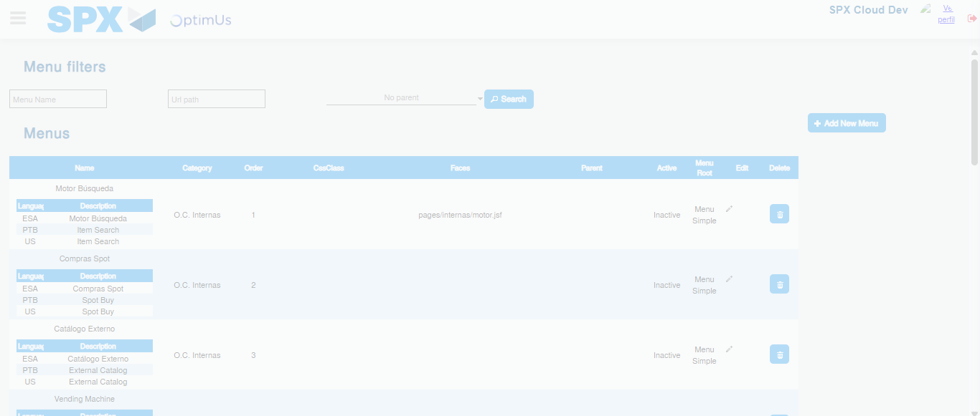Image file-name: QC_Testing-tc008_SPX_Dev5_Validacion_Boton_Remove_Administrador_Menu-nov. 20 2025, 02 43 25 p. m.

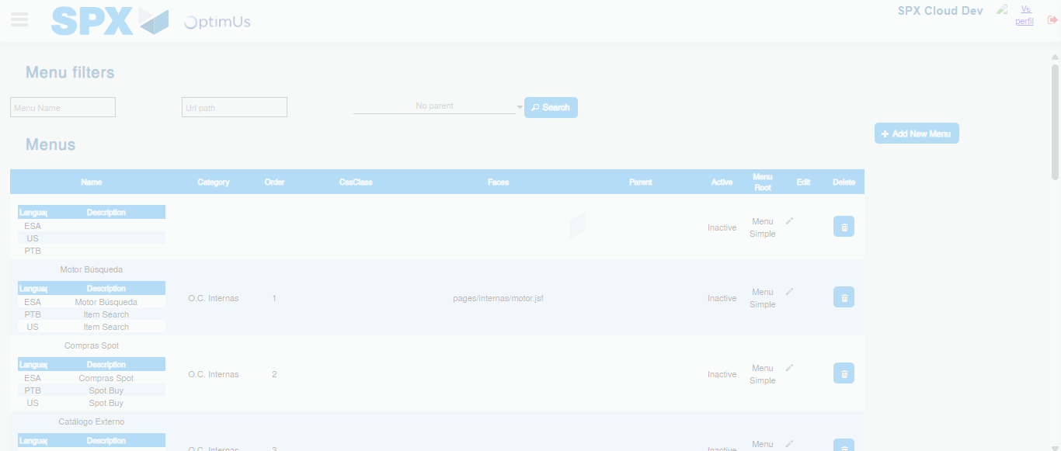Image file-name: QC_Testing-tc008_SPX_Dev5_Validacion_Boton_Remove_Administrador_Menu-nov. 20 2025, 02 43 28 p. m.

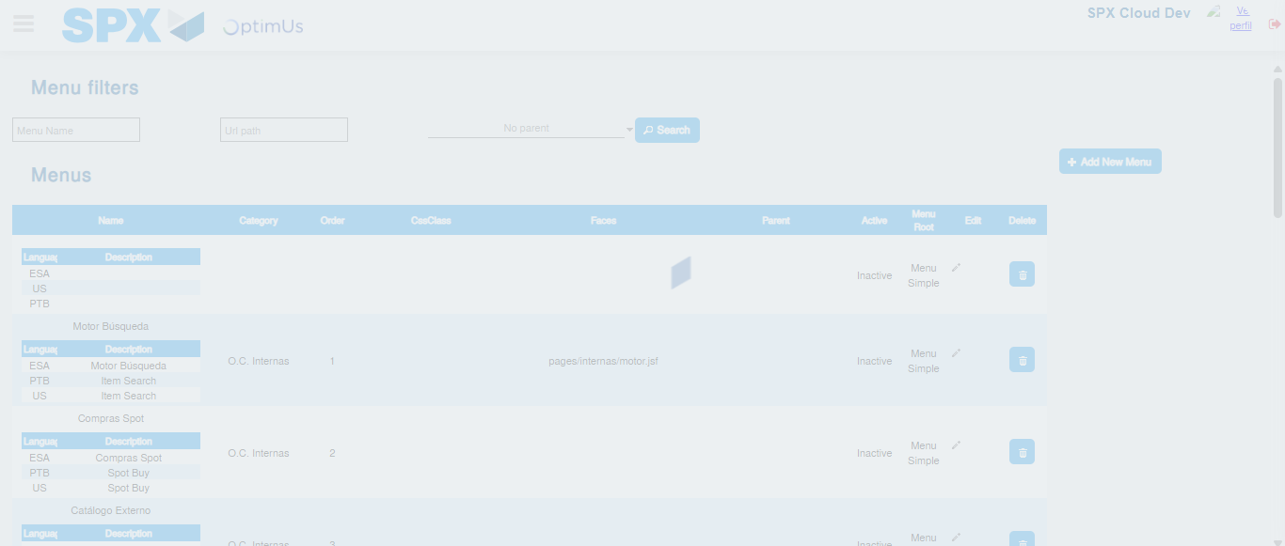Image file-name: QC_Testing-tc008_SPX_Dev5_Validacion_Boton_Remove_Administrador_Menu-nov. 20 2025, 02 43 29 p. m.

